|  |
| --- |
|  |
| 新概念 3 册 |
| Lesson39 Nothing to worry about |

Book

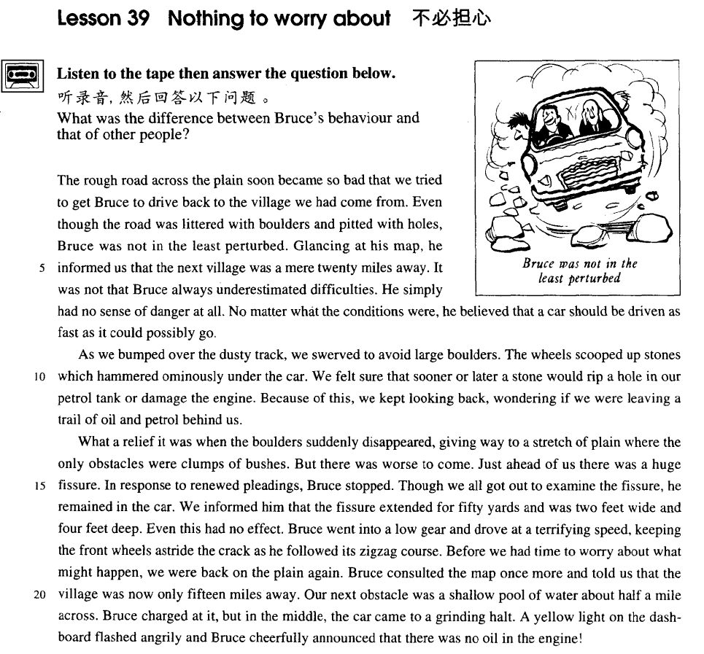

课文

The rough road across the plain soon became so bad that we tried to get Bruce to drive back to the village we had come from.

穿越平原的道路高低不平，开车走了不远，路面愈加崎岖。我们想劝说布鲁斯把车开回我们出发的那个村庄去。

Even though the road was littered with boulders and pitted with holes, Bruce was not in the least perturbed.

尽管路面布满石头，坑坑洼洼，但布鲁斯却一点儿不慌乱。

Glancing at his map, he informed us that the next village was a mere 20 miles away.

他瞥了一眼地图，告诉我们前面再走不到20英里就是一个村庄。

It was not that Bruce always underestimated difficulties. He simply had no sense of danger at all.

这并不是说布鲁斯总是低估困难，而是他压根儿没有一点儿危险感。

No matter what the conditions were, he believed that a car should be driven as fast as it could possibly go.

他认为不管路面情况如何，车必须以最高速度前进。

As we bumped over the dusty track, we swerved to avoid large boulders.

我们在尘士飞扬的道路上颠簸，车子东拐西弯，以躲开那些大圆石。

The wheels scooped up stones which hammered ominously under the car.

车轮搅起的石块锤击车身，发出不祥的锤击声。

We felt sure that sooner or later a stone would rip a hole in our petrol tank or damage the engine.

我们想念迟早会飞起一个石块把油箱砸开一个窟窿，或者把发动机砸坏。

Because of this, we kept looking back, wondering if we were leaving a trail of oil and petrol behind us.

因此，我们不时地掉过头，怀疑车后是否留下了机油和汽油的痕迹。

What a relief it was when the boulders suddenly disappeared, giving way to a stretch of plain where the only obstacles were clumps bushes.

突然大石块不见了，前面是一片平地，唯一的障碍只有一簇簇灌木丛。这使我们长长地松了口气。

But there was worse to come. Just ahead of us there was a huge fissure.

但是更糟糕的事情在等着我们，离我们不远处，出现一个大裂缝。

In response to renewed pleadings, Bruce stopped.

我们再次央求布鲁斯小心，他这才把车停了下来。

Though we all got out to examine the fissure, he remained in the car.

我们纷纷下车察看那个大裂缝，他却呆在车上。

We informed him that the fissure extended for 50 yards and was two feet wide and four feet deep.

我们告诉他那个大裂缝长50码，宽2英尺，深4英尺。

Even this had no effect.

这也没有对他产生任何影响。

Bruce went into a low gear and drove at a terrifying speed, keeping the front wheels astride the crack as he followed its zigzag course.

布鲁斯挂上慢档，把两只前轮分别搁在裂缝的两边，顺着弯弯曲曲的裂缝，以发疯的速度向前开去。

Before we had time to worry about what might happen, we were back on the plain again.

我们还未来得及担心后果，车已重新开上了平地。

Bruce consulted the map once more and told us that the village was now only 15 miles away.

布鲁斯又看了一眼地图，告诉我们那座村庄离我们只有15英里了。

Our next obstacle was a shallow pool of water about half a mile across.

下一个障碍是一片约半英里宽的浅水塘。

Bruce charged at it, but in the middle, the car came to a grinding halt.

布鲁斯向水塘冲去，但车开到水塘当中，嘎吱一声停住了。

A yellow light on the dashboard flashed angrily and Bruce cheerfully announced that there was no oil in the engine!

仪表盘一盏黄灯闪着刺眼的光芒，布鲁斯兴致勃勃地宣布发动机里没油了！

词汇讲解

* **boulder** ['bəuldə(r)] n. （风化的）大圆石头

**boulder**  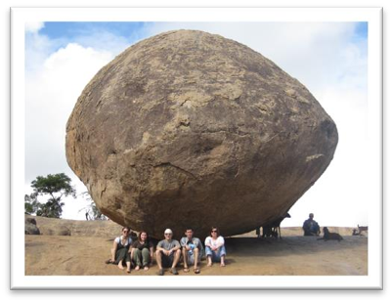

**stone**  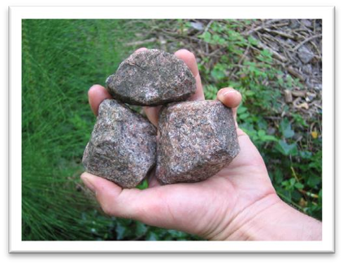

**Rock**  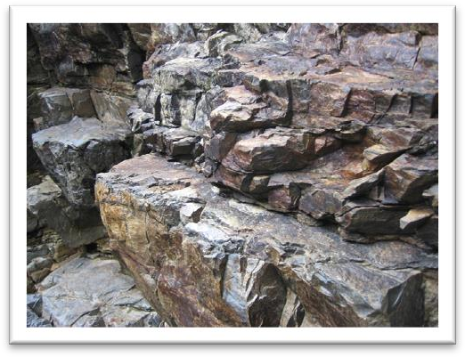

**pebble** 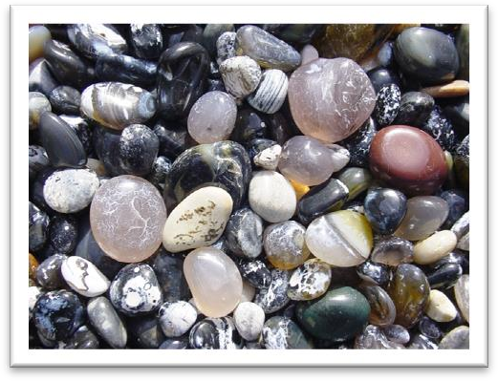

**fossil**  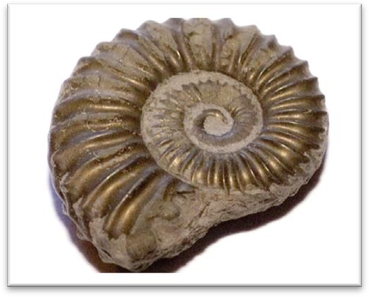

* **perturb** [pə'tɜ:b] v. 使不安
* The letter shocked and **disturbed** / **perturbed** me.
* It is **disturbing** / **perturbing** to think that a dangerous wild animal is still at large in the quiet countryside.
* Ministers declared themselves profoundly **disturbed** / **perturbed** by the violence.

**【词根】**

“**turb**” = **stir**搅拌

**disturb** v.打扰；干扰；妨碍

**perturb** v.使焦虑；使不安

**turbine** n. 轮机；汽轮机

**turbid** adj. 浑浊的；污浊不清的

* **turbid** water 浑水

**turbulent** adj. 动荡的；动乱的；骚动的；混乱的; 汹涌的；猛烈的；湍动的

* **turbulent** waves 汹涌的玻璃
* the **turbulent** times of the French Revolution 动荡的时期
* **underestimate** [ʌndər'estɪmeɪt] **v. 低估**
* Never **underestimate** the power of the press.

**【近义词】【反义词】【相关词汇】**

**overestimate** 高估

* He tends to **overestimate** his own abilities.

**underrate** 对……评价过低

* As an actor, he is seriously **underrated**.

**overrate** 对……评价过高

* In my opinion, she is a hugely **overrated** singer.

**understate** 对……轻描淡写

* It would be a mistake to **understate** the seriousness of the problem.

**overstate** 对……过分夸张

* He may have **overstated** his ability in the interview.

**underplay** 贬低……

* She **underplays** her achievements.

**overplay** 过分强调……

* You must not **overplay** his part in the negotiations.
* **swerve** [swɜ:v] v. 突然转向

**【近义词组】**表达“**转弯**”：

**swerve**

**turn**

**veer**

* As we bumped over the dusty track, we **swerved** to avoid large boulders.
* The lorry **swerved** sharply to avoid the child.
* He **swerved** suddenly, narrowly missing a cyclist.
* After the alarm had been given, the great ship **turned** sharply to avoid a direct collision.
* Moments before crashing, the jet was seen **veering** sharply to the right.

**change course** （专指飞机或轮船）

* The plane **changed course** to avoid the storm. unswerving

**【同根词】**

**unswerving** adj. 坚定的；不懈的；始终如一的

**unswerving** loyalty / belief / support …鉴定的忠诚/信仰/支持

* **ominously** ['ɒmɪnəslɪ] adv. 不吉利地，不祥地
* I went into the kitchen and found him lying **ominously** still on the floor.

**ominous** adj. 不祥的；恶兆的；不吉利的

* There was an **ominous** silence at the other end of the phone.

**omen** n.  预兆；前兆；征兆

* a good / bad **omen**
* He was convinced that seeing the black cat was a bad **omen**.

**【扩展】**

**auspicious** adj. 吉利的；吉祥的

* It was an **auspicious** date for a wedding.
* They won their first match of the season which was an **auspicious** start / beginning.

**inauspicious** adj.预示前景黯淡的；不祥的；不吉利的

* He made an **inauspicious** start to his career by breaking a leg in his first race.
* There has long been a superstition among the Chinese that seeing a magpie is an **auspicious** **omen**.
* There has long been a superstition among the Chinese that hearing the crowing of a crow is an **ominous** **omen**.
* **rip** [rɪp] v. 撕破，扯破

**及物动词用法：**

* I **ripped** my jeans on the fence.
* The flags had been **ripped** in two.
* The nail **ripped** a hole in my jacket.
* She **ripped** the letter open.

**不及物动词用法：**

* Be careful with that dress; it **rips** easily.

**【近义词组】**同义替换

**tear** (tore torn tearing) 撕裂；撕碎；扯破；戳破

* She realized she had **torn** her jacket on a nail.
* I **tore** a hole in my jeans.
* He **tore** the letter in two.
* I **tore** open the package.
* Careful, the fabric **tears** very easily.

**【近义词组】**

**split** (split split splitting) 分裂，使分裂

* One of the boxes had **split** open.
* Her dress had **split** along the seam.
* Don't tell me you've **split** another pair of pants!
* **petrol** ['petrəl] n. 汽油

**petrol** 【英式】汽油

**gasoline / gas** 【美式】汽油

**petrol tank** 【英式】油箱

**gas tank** 【美式】油箱

**petrol / service station** 【英式】加油站

**gas station** 【美式】加油站

**【相关词汇】**

**petroleum** 石油；原油

**crude** **oil** 原油

**OPEC**: Organization of Petroleum Exporting Countries 石油出口国组织

* **obstacle** ['ɒbstəkl]n. 障碍物（一般指道路上的障碍物）
* The area was full of streams and bogs and other natural **obstacles**.

**obstacle to …** 通向…的障碍

* **obstacles to** world peace
* The tax **puts obstacles in the way of** （阻碍了…）companies trying to develop trade overseas.

**【近义词组】**

**block** 障碍物；阻碍；妨害

* a **block** in the pipe / drain

**block to …**通向…的障碍

* The government's stubborn attitude was a **block to** further talks.

**hindrance to …**通向…的障碍

* The higher interest rates have been a **hindrance to** economic recovery.
* To be honest, she was more of a **hindrance than a help**（帮倒忙）**.**

**barrier** 障碍；阻力；关卡

* The crowd had to stand behind **barriers**.
* the language **barrier** 语言障碍

**barrier to …** 通向…的障碍

* Lack of confidence is a psychological **barrier to** success.

**impediment** 妨碍；阻碍；障碍；口吃；结巴

* a **speech impediment** 口吃

**impediment to …** 妨碍…

* War is one of the greatest i**mpediments to** human progress.
* **renew** [rɪ'nju:] v. 更新，换新；继续；延期
* **renew**（更新） the water in the goldfish bowl
* The window frames need to be **renewed**（更新）.
* We **renewed**（继续） our journey the next day.
* I need to **renew**（延期） my passport this year.

**【形容词形式】**

**renewed** 英文解释：adj. happening again with increased interest or strength [only before noun] **更强烈的……**

* **renewed** **determination** / **enthusiasm** 更坚定的决心/更强烈的热情
* **Renewed** fighting has been reported on the border.
* In response to **renewed** pleadings, Bruce stopped.
* **pleading** ['pli:dɪŋ] n. 恳求；adj. 恳求的

**pleading** 英文解释：n. an act of asking for sth. that you want very much, in an emotional way

* He simply ignored my **pleading**.
* **pleading** eyes
* a **pleading** tone of voice plead

**【动词形式】**

**plead for …** 肯求得到…

* Civil rights groups **pleaded for** government help.
* He was on his knees, **pleading for** forgiveness.

**plead with sb. to do sth.** 肯求某人做某事

* Moira **pleaded with** him **to** stay**.**
* She **pleaded with** himnot **to** leave her alone.

**plead** ignorance（无知） / illness（生病） / a headache（头疼） / tiredness（疲劳） / insanity（精神病） 以…/…/…/…/…/为借口

* Ellie **pleaded tiredness** and went to bed very early.
* She stayed home from work, **pleading illness**.
* No one can **plead ignorance** of a subject any longer, for there are countless do-it-yourself publications.

课文讲解

# （第一段）

# The rough road across the plain soon became so bad that we tried to get Bruce to drive back to the village we had come from.

**语法分析：**

The rough road *across the plain（后置定语）* soon became so bad **that**（that... 引导结果状语） we tried to get Bruce to drive back to the village we had come from（定语从句）.

知识点（1）

**get sb. to do** 说服某人做某事

* He **got** his sister **to** help him with his homework.
* We couldn't **get** him **to** sign the agreement.

**【扩展】**复习

**persuade sb. to do / into doing** 说服某人做某事

* I finally managed to **persuade** her **to** go out for a drink with me.
* Don't let yourself be **persuaded into buying** things you don't want.
* In their efforts to p**ersuade us to buy** this or that product, advertisers have made a close study of human nature and have classified all our little weaknesses.

**talk sb. into doing** 说服某人做某事

* We finally **talked** Father **into buying** the new car.

**【扩展】**反义表达

**get sb. not to do** 劝阻某人不做某事

**persuade sb. not to do / out of doing** 说服某人不做某事

**talk sb. out of doing** 说服某人不做某事

**dissuade sb. from doing** 劝阻某人不做某事

# Even though the road was littered with boulders and pitted with holes, Bruce was not in the least perturbed.

**语法分析：**

**Even though**（“尽管”，引导让步状语从句） the road was littered with boulders and pitted with holes, Bruce was not in the least（一点也不） perturbed.

知识点（1）

**be littered with …** 杂乱的堆满…

* The garden **was** soon **littered with** chunks of metal which had once made up a lawn mower.

**litter** vt. 杂乱的堆满某地

* There is always hope that in its labyrinth of musty, dark, disordered rooms a real rarity will be found amongst the piles of assorted junk that **litter the floors**.

**【扩展】**

**be pitted with …** 到处是坑洞

* The road **was pitted with** holes.
* His face **is pitted with** smallpox.

**be dotted / scattered with …** 散乱的分布着

* The sky **is ~ with** stars.
* The lawn **is ~ with** pine trees.

**【复习】**

**be covered with …** 布满了

* Before she had anchored, the men from the boats had climbed on board and the decks were soon **covered with** colourful rugs from Persia, silks from India, copper coffee pots, and beautiful handmade silverware.

**be loaded with …** 满载着…

* Small boats **loaded with** wares sped to the great liner as she was entering the harbour.

**be filled with …** 装满了某个东西、充满了某种感情

* … it is **filled with** what looks like a thick, greyish substance.
* All at once, I noticed that my wife seemed to be **filled with alarm**.

**be packed / crammed with …** 挤满了

* The streets **were packed / crammed with** Christmas shoppers.
* It has been estimated that if the bridge **were packed with** cars, it would still only be carrying a third of its total capacity.

**be stuffed with …** 中间填满了

* a pillow **stuffed with** feathers
* duck **stuffed with** ‘eight treasures’ 八宝鸭
* **stuffed** birds 鸟类标本
* I’m **stuffed**. = I’m full.

知识点（2） Lesson17

**语法：**“一点也不”“绝不”置于句首部分倒装

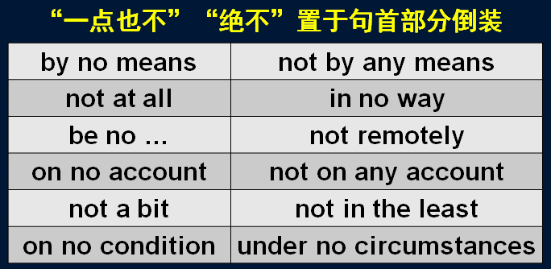

* Though Verrazano is **by no means** considered to be a great explorer, his name will probably remain immortal, for on November 21st, 1964, the longest suspension bridge in the world was named after him.
* She is **by no means** pretty.
* She's **not** a bad kid, **by any means**.
* **By no means can**theory be separated from practice. （倒装）
* She's **not at all** happy about the current situation.
* This will **in no way** influence our original decision.
* I **am no** expert.
* That girl **is no** fool.
* Larry **is no** friend of mine.
* His arguments are **not remotely** convincing.
* **On no account** *must*you disturb me when I'm working.
* Do **not on any account** leave the prisoner unguarded. （倒装）
* I tried to convince them, but they were**n't in the least interested.**
* "Was she annoyed?" "**Not a bit**! She was delighted."
* **On no condition *should*** untrained personnel use the equipment. （倒装）
* **Under no circumstances *will*** we agree to splitting up the company. （倒装）

**【辨析】**

**not a little** = **more than a little** = **very** 特别的、非常的

* Graham was **not a little / more than a little** frightened by what he had seen.

知识点（3）

**perturbed** = **disturbed** = **worried**

# Glancing at his map, he informed us that the next village was a mere 20 miles away.

**语法分析：**

Glancing at his map（非谓语动词作伴随状语), he informed us *that the next village was a mere 20 miles away（宾语从句）*.

知识点（1）

glance at … 匆匆的看…

知识点（2）

**inform sb. of / about sth.** 通知某人某事

**inform sb. that …** 通知某人某事（从句）

**convince sb. of sth.** 使某人相信某事

**convince sb. that …** 使某人相信某事（从句）

知识点（3） Lesson34、Lesson37

**a mere …** 仅仅……

1. **a mere** 后跟单数名词时 = **only a / an**
2. 在其他情况下 **a mere = only**

* ① **a mere** 后跟单数名词时
* It went direct from my local station and the journey lasted **a mere** (=**only an**) hour and 17 minutes.
* He's **a mere** (=**only a**) child.
* He's not **a mere** (=**only a**) boxer: he's world champion.
* ② 在其他情况下 **a mere = only**
* **A mere** (=**Only**) 2% of their budget has been spent on publicity.
* He has often described to me how he picked up a masterpiece for **a mere** (=**only**) £50.
* Glancing at his map, he informed us that the next village was **a mere** (=**only**) twenty miles away.

# It was not that Bruce always underestimated difficulties. He simply had no sense of danger at all.

**两个句子改写，合并:**

**It was not that** Bruce always underestimated difficulties, **but (that)** he simply had no sense of danger at all.

知识点（1）

**It is/was not that …, but (that) …** 不是因为……, 而是因为……

* **It was not that** I actually remembered anything at all. **But** my father had described over and over again what we should see at every milestone, after leaving the nearest town, so that I was positive I should recognize it as familiar territory.
* **考研英语，英译汉：**
* **It is not that** the scales in the one case, and the balance in the other, differ in the principles of their construction or manner of working; **but that** the latter is a much finer apparatus and of course much more accurate in its measurement than the former.

**not that …, but that …** （简化，要求平行结构）不是因为……, 而是因为……

* **Not that** I love Caesar less, **but that** I love Rome more. — Shakespeare ‘Julius Caesar’
* **Not that** I love you less, **but that** I love liberty more.
* **Not that** I love my teacher less, **but that** I love truth more.

知识点（2）

**simply** adv. used to emphasize what you are saying（用以加强语气）简直，实在，根本，就是

* He **simply** had no sense of danger at all.
* His pronunciation is **simply** terrible.
* That is **simply** not true!
* I **simply** refuse to go!
* He **simply** won't accept the committee's decision.

# No matter what the conditions were, he believed that a car should be driven as fast as it could possibly go.

**语法分析：**

**No matter** （引导让步状语从句）what the conditions were, he believed ***that*** *a car should be driven as fast as it could possibly go（比较状语从句)*. *（****that****…宾语从句）*

知识点（1）

**语法复习：**让步状语从句

No matter what the conditions were …

= **Whatever** the conditions were, …

知识点（2）

**possibly** 经常与 can / could连用以表示“尽全力”的意思，后跟动词时常用can / could possibly + 动词，后省略动词时常用 possibly can / could。

* No matter what the conditions were, he believed that a car should be driven as fast as it **could possibly** *go*. （前后动词不一致，不可省略）
* She's done everything she **could possibly** *think of* to help. （前后动词不一致，不可省略）
* We shall be contributing as much as we **possibly can** to the campaign.
* Doctors did everything they **possibly could** to save his life.
* **造句**：无论在任何情况下，他都认为一个人应该尽可能地为社会做出贡献。
* No matter what the conditions were, He believed that a person should contribute as much as he **possibly could** to society.
* **造句**：无论在任何情况下，他都认为一个人应该为社会做出他能想到的尽可能多的贡献。
* No matter what the conditions were, He believed that a person should make as many contributions **as he could possibly** *think of* to society.

# （第二段）

# As we bumped over the dusty track, we swerved to avoid large boulders.

知识点（1）

**bump** v. 碰撞

* Be careful not to **bump** your head.
* In the dark I **bumped** ***into***a chair.
* The car **bumped** ***against***the curb.

**bump *over / across / along / down* …** 颠簸前进

* As we **bumped *over*** the dusty track, we swerved to avoid large boulders.
* A police car **bumped *down***the track.
* The old bus **bumped *along***the mountain road.
* The airplane **bumped *across*** a field before finally coming to a stop.

知识点（2）

**track** 英文解释：n. a narrow path or road with a rough uneven surface, esp. one made by vehicles, people or animals （人踩出的）小道，小径

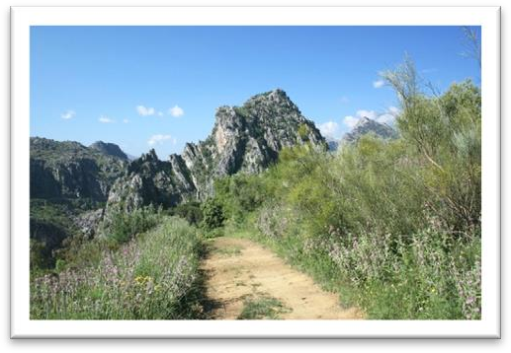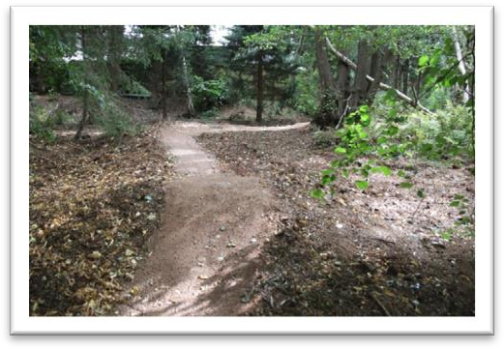

# The wheels scooped up stones which hammered ominously under the car.

知识点（1）

**scoop** 英文解释：n. a tool with a deep bowl-shaped end which is used to dig out and move a soft or powdery substance 勺；铲子

* a measuring scoop

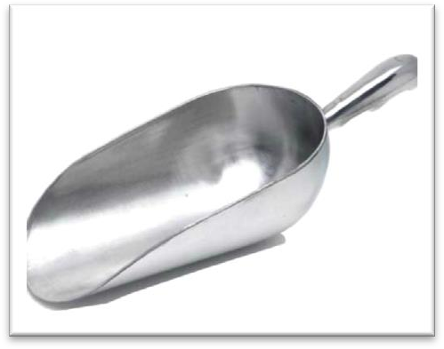

* an ice-cream scoop

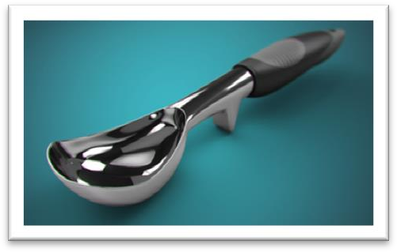

* a scoop of ice-cream

**动词形式：**

**scoop (up / out) sth.** 勺出来

* He **scooped water** from the stream and splashed it on his face.
* She bent down and **scooped up** the little dog.
* Carefully **scoop out** the pulp with a small spoon. hammer / thunder

知识点（2）

**名词动用：**

**hammered** / **thundered** 重击

* He **hammered** / **thundered** at the door.
* It immediately ran away when she saw it, and experts confirmed that a puma will not attack a human being unless it is **cornered**.
* He **elbowed** his way through the crowd.
* I am **fogged** by the issue.
* The lady **housed** the homeless.

# We felt sure that sooner or later a stone would rip a hole in our petrol tank or damage the engine.

**语法分析：**

We felt sure **that** *sooner or later（迟早）* a stone would rip a hole in our petrol tank or damage the engine. （**that**... 形容词补足语）

知识点（1）

**sooner or later** 迟早，早晚有一天

* You should tell her, because she'll find out sooner or later.

知识点（2）

**rip / tear a hole** 撕一个口子

# Because of this, we kept looking back, wondering if we were leaving a trail of oil and petrol behind us.

**语法分析：**

*Because of this（原因状语)*, we kept looking back, **wondering** **if** we were leaving a trail of oil and petrol behind us（**if**… 宾语从句）. （**wondering…** 非谓语动词作伴随状语)

知识点（1） Lessson1

**leave a trail of … behind …** 在…后面留下了一连串的…

* The hurricane **left a trail of** destruction **behind** it.
* The bus **left a trail of** black smoke **behind** it.
* He left **a trail of** muddy footprints **behind** him.
* Wherever it went, it left *behind it* a trail of dead deer and small animals like rabbits.

# （第三段）

# What a relief it was when the boulders suddenly disappeared, giving way to a stretch of plain where the only obstacles were clumps bushes.

**语法分析：**

What a relief it was **when** the boulders suddenly disappeared, ***giving*** *way to a stretch of plain where the only obstacles were clumps of bushes（定语从句，修饰plain）*. *（****giving****… 非谓语动词引导结果状语)*（**When**... 时间状语）

知识点（1）

**relief** n. 宽慰，痛苦的缓解或解脱

* find a temporary **relief** 临时解脱
* permanent **relief** 永久解脱
* to my great **relief** 大为宽心宽心
* give immediate **relief** from pain 立刻缓解了疼痛

知识点（2）

**give way to sth.** 1. 被（更新更好的事物）代替

* Steam trains **gave way to** electric trains.
* Winter **gave way to** spring. 冬去春来
* The storm **gave way to** bright sunshine.

**give way to sb. / sth.** 2. 让路，向……屈服

* Drivers must **give way to** cyclists.
* **Give way to** traffic coming from the right.
* We must not **give way to** their demands.

知识点（3）

**stretch** 英文解释：n. an area of land or water, esp. one that is long and narrow （狭长的）一片或一段地或水域

**stretch of …** 一片

* **a stretch of** plain 一片平原
* **a** narrow **stretch of** water 一片狭长的水域
* **a** beautiful **stretch of** countryside 一片美丽的风光
* **a** particularly dangerous **stretch of** road 一段特别危险的道路

知识点（4）

**clump** 英文解释：n. a group of trees, bushes, or other plants growing very close together 丛

**a clump of trees / bushes / flowers / grass**  一从…

# But there was worse to come. Just ahead of us there was a huge fissure.

知识点（1）

**worse** 英文解释：n. [U] something worse （做名词）更糟的东西

* I'm afraid there is **worse** to come. 更糟的还在后面
* We thought the situation was bad, but **worse** was to **follow.** 更糟的还在后面
* "What about the bride's dress ― wasn't it appalling?" "I don't know, I've seen **worse**." 我见过更糟的

知识点（2）

**fissure** 英文解释：n. long deep crack in rock or in the earth （岩石中或土地中的）深长裂缝

# In response to renewed pleadings, Bruce stopped.

知识点（1）Lesson18

**in response to …**（to是介词）作为对…的反应

* The president stepped down **in response to** public pressure.
* Oddly shaped forms that are suspended from the ceiling and move **in response to** a gust of wind are quite familiar to everybody.

知识点（2）

**renewed** 英文解释：adj. happening again with increased interest or strength [only before noun] 更强烈的……

# Though we all got out to examine the fissure, he remained in the car.

知识点（1）

**get out** 从车里出来（小车）

**get out of** a car / taxi

**get in** 上车（小车）

**get into** a car / taxi

**get on** 上车（大车）

**get on** a bus / train / ship / plane

**get off** 下车（大车）

**get off** a bus / train / ship / plane

# We informed him that the fissure extended for 50 yards and was two feet wide and four feet deep.

知识点（1）

**extend** v.（时间或空间）延伸

* The Sahara Desert **extends *for*** miles.
* The show has been **extended *for***another six weeks.
* My garden **extends *as far as*** the river.
* The driveway **extends *from***the house ***to***the high way.
* An industrial zone **extends *along*** the river.

# Even this had no effect.

# Bruce went into a low gear and drove at a terrifying speed, keeping the front wheels astride the crack as he followed its zigzag course.

**语法分析：**

Bruce went into a low gear and drove at a terrifying speed, **keeping** the front wheels astride the crack *as he followed its zigzag course（as...时间状语从句）*. （**keeping**... 非谓语动词作伴随状语）

知识点（1）

**gear** 车档

* automatic **gear** 自动挡
* manual **gear** 手动挡
* an automatic **gearbox** 自动变速箱
* a four-speed manual **gearbox** 四速手动变速箱
* Andy drove cautiously along **in** third **gear**. 以第三档位
* Helen **changed gear / gears** （换挡）as she approached the intersection.

**go / move / shift into … gear** 换到了…档位

* I **went / moved / shifted into fourth gear** when I got onto the highway.

**put / slam / slip sth. into … gear** 换到了…档位

* I put / slammed / slipped the car **into fourth gear** when I got onto the highway.

知识点（2）

**1.speed 做不可数名词时，与 at, with 搭配均可**

* at / with great **speed**

**2.speed 做可数名词时，只能与 at 搭配**

* at a **speed** of 60 mph

知识点（3）

**astride** 英文解释：prep. with one leg on each side of sth. 跨在……上

* a photograph of my mother sitting **astride** a horse
* She sat proudly **astride** her new motorbike.
* The town lies **astride** a river.

知识点（3）

**zigzag** 英文解释：adj. a pattern that looks like a line of z's joined together 之字形，Ｚ字形

* a **zigzag** path along the cliff

# Before we had time to worry about what might happen, we were back on the plain again.

**语法分析：**

**Before** we had time to worry about what might happen（宾语从句） （**Before**... 时间状语）, we were back on the plain again.

# Bruce consulted the map once more and told us that the village was now only 15 miles away.

**语法分析：**

Bruce consulted the map once more and told us that the village was now only 15 miles away（宾语从句）.

# Our next obstacle was a shallow pool of water about half a mile across.

知识点（1）Lesson15

**语法**、**注意：名词前有量词，形容词放在量词前**

* a nice **cup**of tea 一杯好茶
* a beautiful **stretch**of field 一片美丽的田野
* a stagnant **pool**of water 一潭死水
* For most of them, 50 pence is a small price to pay for a nice **big** ***bar***of chocolate.

# Bruce charged at it, but in the middle, the car came to a grinding halt.

知识点（1）

**charge at …** 朝……猛冲

* Suddenly the bear **charged at** us.
* He **charged at** me with his fists flying.

知识点（2） Lesson6

**come to a stop / halt / standstill** 停止

* It **came to a stop** outside the jeweler’s.

知识点（3）

**grind** 磨擦（发出刺耳声）

* come to a **grinding** halt

知识点（4）

**come to…** 进入某种状态

* **come to an end / a close**
* **come to** **a decision / conclusion / agreement**

# A yellow light on the dashboard flashed angrily and Bruce cheerfully announced that there was no oil in the engine!

**语法分析：**

A yellow light *on the dashboard介词短语当后置定语）* flashed angrily and Bruce cheerfully announced *that there was no oil in the engine（宾语从句）*!

知识点（1）

**flash angrily** 发出刺眼的强光

* Sparks were emitted from small black boxes and red lamps **flashed** on and off **angrily**.